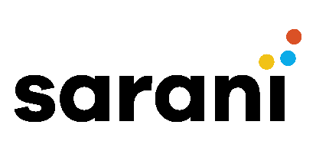
11 November 2025
Service proposal:
80 x German Animated Videos
This proposal is for Lu Meng at TikTok.
Purpose of work
TikTok requires the creation of 80 animated videos in German.
Scope and deliverables
- 80 × German animation SFVs

Project schedule
This schedule is based on estimated timelines and subject to change.
- Proposal delivered to TikTok – 11 November 2025
- Work commences once PO is raised
- Final work to be delivered to TikTok by specified deadline

Pricing, payment, terms and conditions
The total pricing for this work is 9,600$ USD for 80 videos.
Item | Fixed rate ($) | Quantity | Total ($ USD)
Advanced Videos Edition | 120 | 80 | 9,600
 |  | Total | $ 9,600

They can be reviewed based on final requirements.
References
As a complementary information, our background comes from broadcast television - from entertainment to drama, documentary and live:
- We have worked across all genres, with all walks of life from Hollywood A-listers, top CEOs and members of the public.
- Our team is multi-award winning in both film direction and live production, and includes 1 Emmy Award and 3 Bafta Awards.
Work commences once a PO is raised.
- Unlimited rounds of revisions are offered before filming and on post-production.
- Payment terms are 45 days.

Best regards,
Emmanuel Gomez, CEO, Sarani

